**Experiment No. 10**

* 1. **Experiment Name**

Simulation on Maximum Power Point Tracking (MPPT) algorithm of Photovoltaic system

(solar)

* 1. **Objectives**
* To develop and study a Photovoltaic system (solar) using Simulink
* To get acquainted with Maximum Power Point Tracking (MPPT) algorithm
* To get familiarize with the Simulink platform and Simulink library
* To use the Simulink platform to construct and analyze the I-V and P-V characteristics curve of the system
  1. **Apparatus**
* Simulink
  1. **Simulink Block Diagram & Waveform**

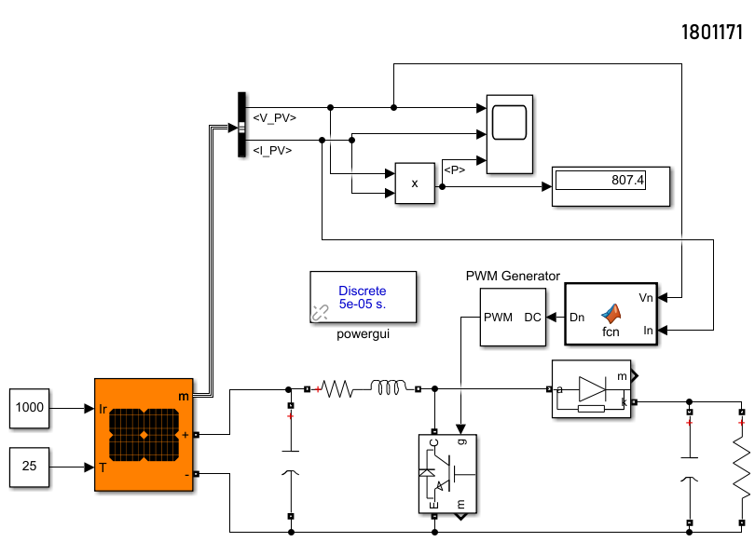

Fig.10.1: Block diagram of a Photovoltaic system (solar) for Maximum Power Point Tracking (MPPT)

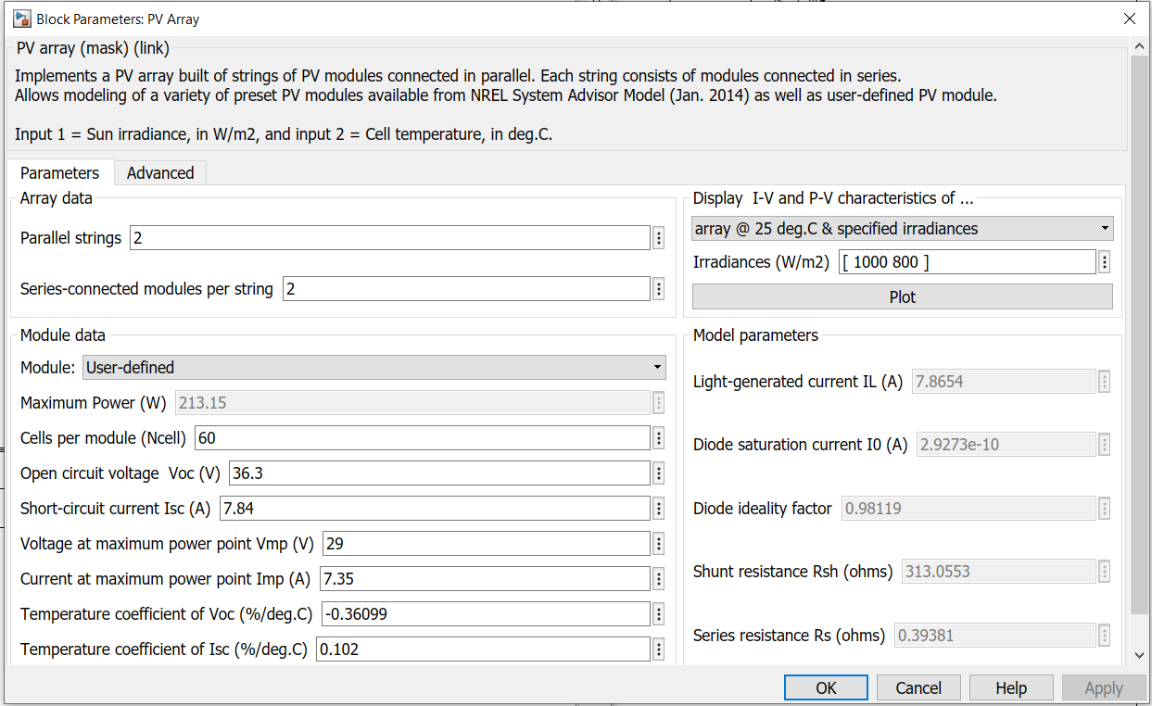

Fig.10.2: Block parameters of the PV array used in Photovoltaic system (solar)

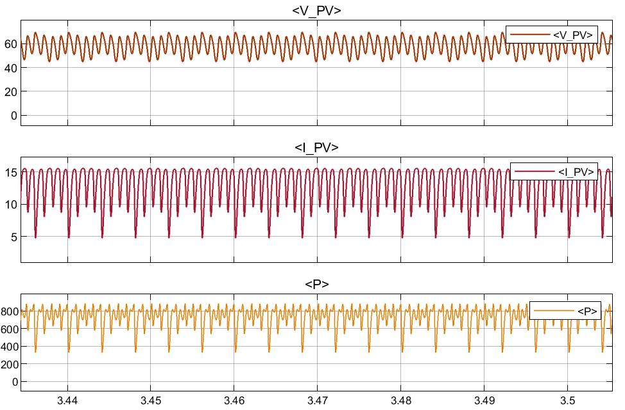

Fig.10.3: Voltage, current, and power waveform of PV array

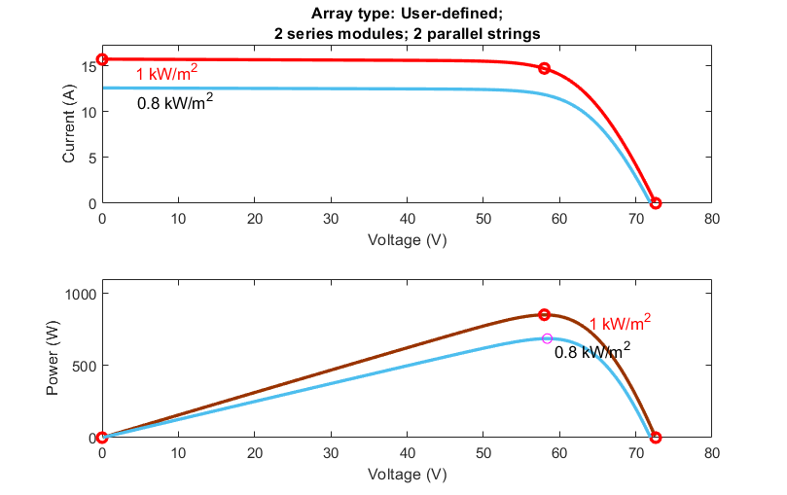

Fig.10.4: I-V and P-V characteristics of defined PV array at 25o Celsius and specified irradiances

**MATLAB Code**

function Dn = fcn(Vn,In)

delta = 0.001;

Dmax = 0.9;

Dmin = 0.05;

persistent Po if isempty(Po); Po = 100; end

persistent Vo if isempty(Vo); Vo = 10; end

persistent Do if isempty(Do); Do = 0.5; end

Pn = Vn*In;

dp = Pn-Po;

dv = Vn-Vo;

if ((dp/dv)>0)

Dn = Do-delta;

elseif ((dp/dv)<0)

Dn = Do+delta;

else

Dn = Do;

end

Do=Dn;

Po=Pn;

Vo=Vn;

if Dn>Dmax

Dn = Dmax;

elseif Dn<Dmin

Dn = Dmin;

else Dn = Dn

end

y = Dn;

end

* 1. **Discussion & Conclusion**

This experiment thoroughly investigated to analyze a Photovoltaic system for Maximum Power Point Tracking (MPPT). Here, we used a solar PV array for analysis. For this system, we utilized connection and value of parameters of the PV array according to our desired preference. This ensured a better characteristics curve for both I-V and P-V. Thus, desired output was observed and the simulation was a success.